**Line Following Robot**

**1.Introduction**

In this lesson is presented a vision based application for a line following robot. The task is to allow the robot to navigate through a predefined path marked by a yellow line.This program use two main classes. One for the detection of the line that obtains images from the robot, performs centroid detection and communicate the required direction for the robot to move in. The second class is used for the navigation of the robot that has 4 direction commands: move forward, turn left, turn right and search(spin until a line is detected) and for publishing the velocity commands after receiving the command from the first class.

**2.Dependencies**

For this program to run optimally you need the next setup:

* Ubuntu 18.04.5 LTS or a Virtual Machine with Ubuntu 18.04.5 LTS
* Gazebo 11
* ROS Melodic Morenia

All the installation tutorials will be in “Chapter 1”

**3.Installation**

All the commands below must be run in a terminal. To open o new terminal press CTRL+ALT+T or RIGHT CLICK and Open Terminal.

Terminal commands are highlighted in yellow.

Se lanseaza in executie programul(Downloading the program from

Github,……)

line_follower_turtlebot

If the download from GitHub is successful, the next message will appear.If the download is successful, the next message will appear.



**cd line_follower**

**catkin_make**

The catkin_make command is a convenience tool for working with catkin workspaces(a catkin workspace is a folder where you modify, build, and install catkin packages).

For every shell that launches programs you need to run this command, to make sure your workspace is properly overlayed by the setup script.

**source devel/setup.bash**

**4.Running the program**

For running this program the next command should be run in terminal. The robot and the world will be automatically spawned and the program will run after the command will be finished successfully.



**roslaunch line_follower_turtlebot lf.launch**

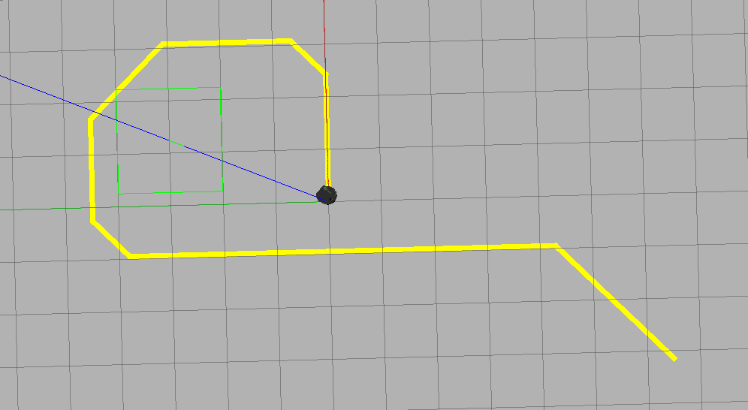

In terminal will appear the moves that robot needs to make to follow the line.

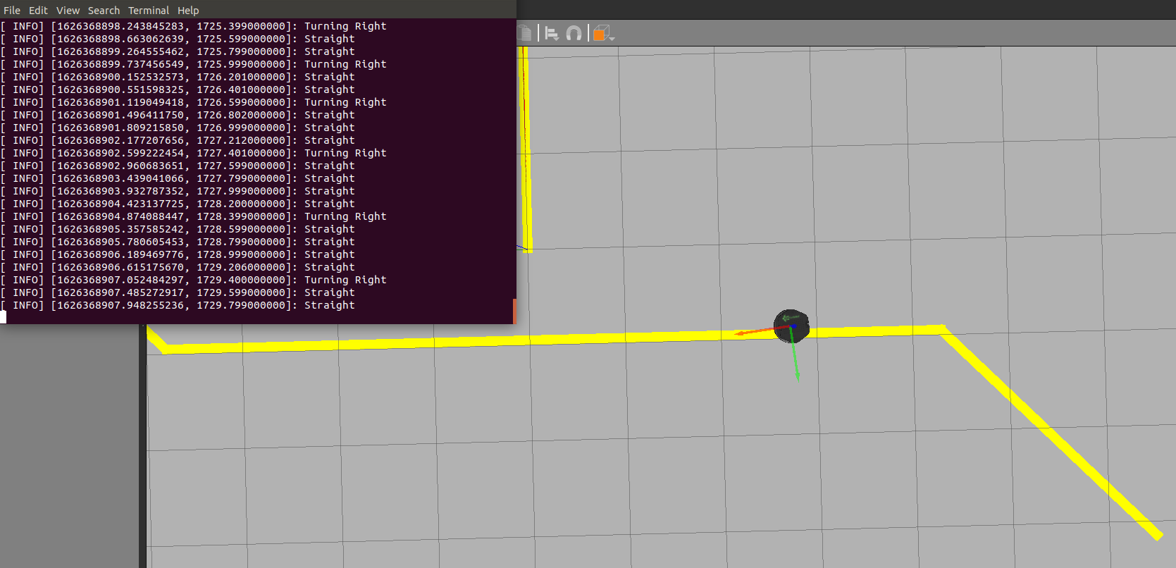

Another window will be opened where you can see the camera view and if the robot is detecting or not a line to follow.

